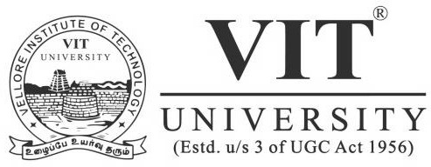

**School of Civil and Chemical Engineering**

**Department of Chemical Engineering**

SIM-A-THON – SYSTEM ALLOCATION INFORMATION WINTER SEMESTER 2016-17

24th - 25th March 2017

STUDENT ACTIVITIES

**SIM-A-THON**

