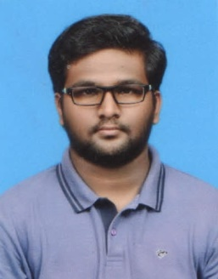
Address: No 3 ,3rd east main road Gandhi Nagar vellore
Mobile/E-mail: 95660 19249/muthukumarbr7@gmail.com
LinkedIn URL: linkedin.com/in/muthu-kumar-72b087101/
Muthukumaraswamy M
Reg. No: 19MBA0056
Statement of Purpose / Career Objective
To secure a challenging position in a reputable organization to expand my learning’s, knowledge, and skills.
Academic Qualification
Qualification | Institute Name | Year of Passing | Percentage
MBA (Finance) | VIT Business School | On going | 93%
UG | RMK engineering college | 2017 | 70%
HSC | MCC.MatricHr Sec School | 2012 | 65 %
Class X | MCC.MatricHr Sec School | 2010 | 69%
Additional Academic Qualification - Professional certification
Course Name | Certified by | Duration From-to | Outcome
FinTech | VIT-TopXight Research labs USA |  | App Creation / research papers
Building Management system | Johnson Control |  | Certification
Internship Project |  |  | 2 Months
A Research paper of Mutual Funds Fact sheets in stock selection
Work Experience
Australian Foods India Pvt Ltd | Executive – Marketing Merchandising Promotion |  | 2017-2018
Live - Projects Pursued / Consultancy
Nil
Projects Pursued (J-Comp)
Ambient RR signal Energy HarvestingB.E
Capstone Project |  |  | Duration
Nil |  |  | From - to
Positions of Responsibility |  |  | Duration
NIL
Skills
Technical |  | Managerial
Technical Analysis of Stock’s in capital market |  | Effective Team Management skills: ability to schedule, monitor and lead a team to deliver optimal  Output as measured by relevance and timeliness.  Leadership skills: capable of taking charge of a situation, making myself an integral part of the  team and driving the team to achieve organizational objectives.
Academic Achievements
Other Achievements
Language Proficiency
 | ead | Write | Speak
English  Tamil | YES  Yes | YES  Yes | YES  YES

