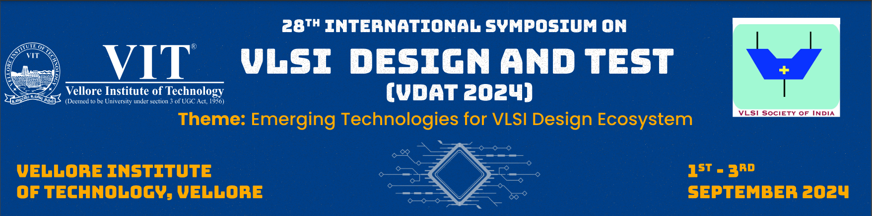

TUTORIAL PROPOSAL TEMPLATE

1. Tutorial Title
Please insert the tutorial title.

2. Instructor Team
Please insert the names, institutions, and emails of the instructors.

3. Abstract
Around 500 words. The tutorials should not be publicity/marketing material of a company. It should cover generic/advance concepts that provide technical insight to the participants. The examples of usage of those concepts can be demonstrated through company specific implementations (tools/chips).

4. Duration of Tutorial
Indicate if the preferred duration is 1.5 hours /2 hours/ 3 hours.

5. Tutorial Outline
Outline shall define the topics and subtopics. Time allocation and instructor breakdown by topics is recommended.

6. Lecture Style and Requirements
Briefly describe the tutorial format, which may include traditional lecture, software/hardware demonstration, interactive audience polls/quizzes, worksheets, discussion, etc. Note any equipment or space requirements beyond a laptop and projector. Also list the targeted audience and tutorial difficulty level, including any pre-requisite knowledge.

7. Instructors Biography
Please insert the bios of the tutorial instructors (< 200 words for each instructor). Each biography shall include the qualifications & experience most relevant to the proposal.

